MCU-based Mini-Weather Station

Prepared for: **Van B. Patiluna,** Instructor  
Prepared by: **Brad Pitt** & **Tom Cruise**, (4:30-7:30 TUE)

1 October 2018

Executive Summary

# Rationale

The Philippines is situated west of the Pacific Ocean and is hit by an average of 30 typhoons per year [1]. Satellite based sensors provides important data to weather agencies such as PAG-ASA but ground based data is also important. Therefore, mini-weather stations shall be deployed throughout the city or municipality to provide more accurate and precise weather forecast and typhoon tracking.

Therefore small, light-weight and power efficient weather devices must be developed to be deployed en mass throughout the locality, especially on the coastal areas including river-sides and land slide prone areas. The solution requires data to be digital as to provide precise measurements of the wind speed, wind direction and air temperature.

The proposed project is a prototype for a weather station which can collect wind speed, wind direction and temperature. This instrument provides real-time data by using a Micrcontroller Unit (MCU). Data from the instrument is displayed on an LCD and is constantly updated.

# Problem

How to gather digital data on wind speed, wind direction and air temperature?

# Goals and Objectives

The goal of this project is to develop a MCU -based mini-weather station capable of measuring wind speed, wind direction and air temperature. Furthermore, the following objectives are to be met:

- study of data on wind speed, wind direction and air temperature;

- development of the instruments such as the anemometer, wind vane and incorporating digital sensors;

- design & development of the electronic systems for the sensors and

- design & development of the software that will perform the task of reading and displaying data from the sensors.

# Scope & Limitation

The project scope involves only the construction of the anemometer and wind vane, the design and implementation of the electronic circuitry required for the sensors including the temperature sensor and the development of the software running on the MCU to perform the task required.

The proposed design has the following limitations:

- precision of the data is up to two (2) decimal places only

- the angular step of the wind vane is 1 degree

- the proponents does not guarantee the accuracy of the temperature sensor available

- maximum airspeed can be measured is 250 kph

- data is not logged in a memory system

# Conceptual Framework

The following is the conceptual framework of the proposed project.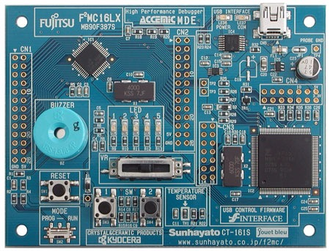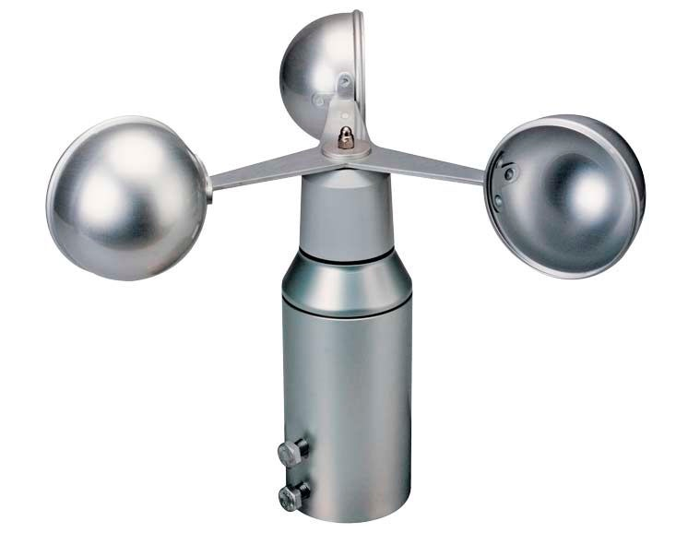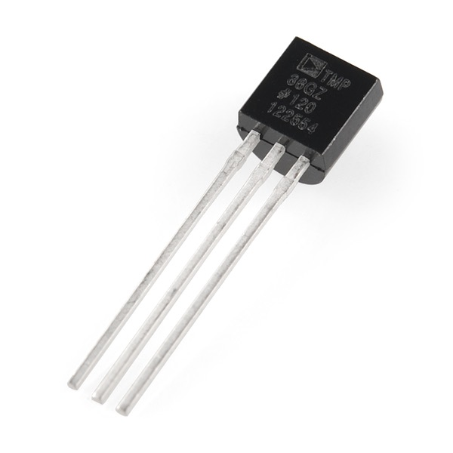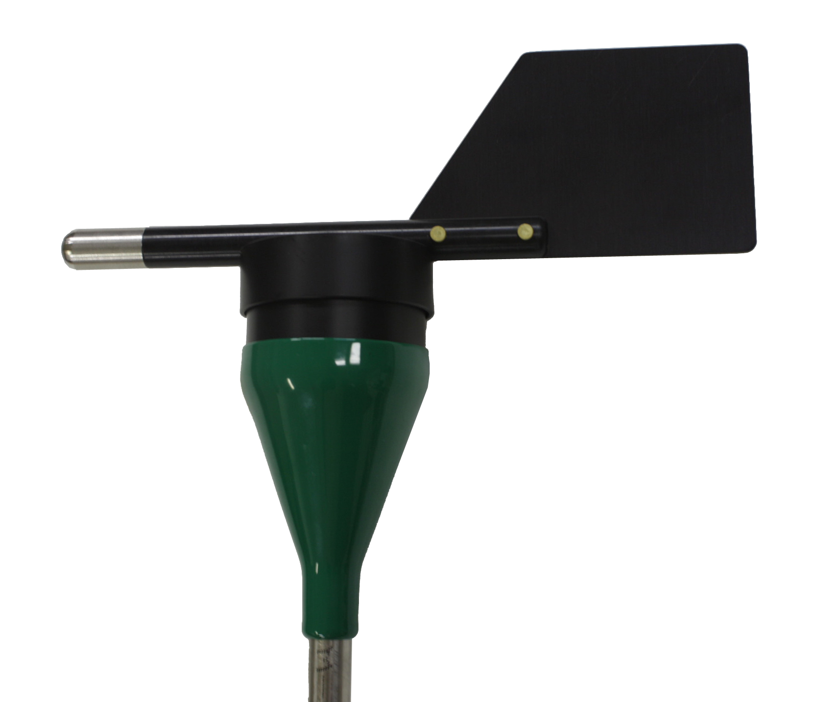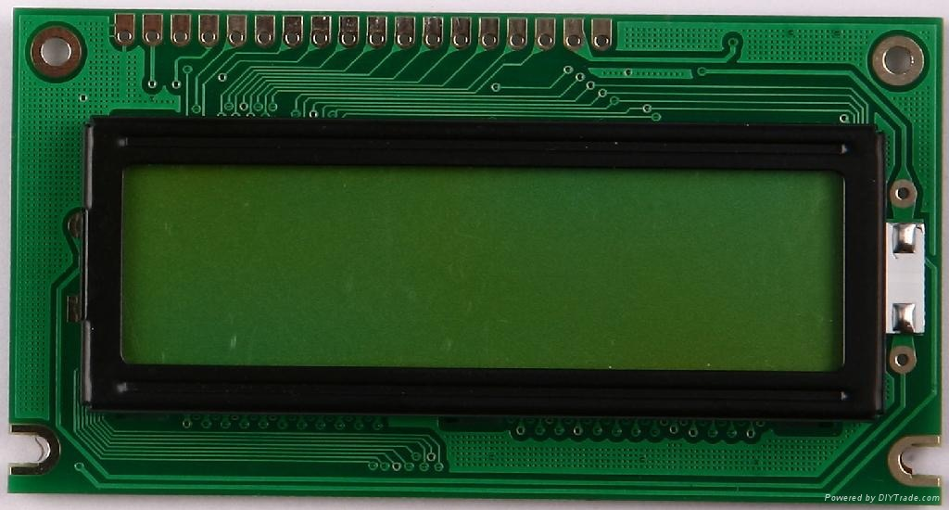

anemometer

wind vane

temperature sensor

display

micro-computer

The air temperature sensor, anemometer and the wind vane are interfaced to the micro-controller through their respective driver circuitry. The LCD display is directly interfaced to the MCU through the assigned GPIO ports. The three sensors gathers data simultaneously and reading the data from each is managed by the software. The data displayed are real-time and is constantly updated.

## System Block Diagram

Potentiometer

Driver

Driver

LCD

Rotary Encoder

MCU

(MB90F387S)

## Hardware Design

The hardware consists primarily of the Fujitsu MB90F387S starter kit and the subsequent sensors. The sensor for the anemometer is through a rotary encoder that provides pulses to the MCU. The frequency of the pulses provides data on the speed the anemometer rotates. The wind vane is implemented using a potentiometer. The voltage output through the potentiometer is fed to the AD converter of the MCU which will be converted into angular displacement. The air temperature sensor will be implemented using an LM35 general purpose temperature sensor. Temperature data is also fed to the other analog input channel of the A/D converter. Air temperature is displayed in degrees Celsius and Fahrenheit.

## Software Design

Due to the real-time constraints of the project, a task scheduler shall be used. The Riverside-Irvine Operating System (RIOS) will be used as the task scheduling mechanism. The system has a total of four (4) tasks namely: Read Wind Speed, Read Wind Direction, Read Temperature and Display Data. RIOS provides a lightweight code suitable for MCU applications and is also easy to generate the tasks. The task can be also designed as a state machine if required.

# Project Management

## Team Composition

**Brad Pitt** (Team Leader/Hardware Lead) - Is responsible for the management of the project as well as the development of the task scheduler. Represents the team to the instructor.

**Tom Cruise** (Member/Software Lead) - Assists the team leader and is in-charge for the development of the hardware circuitry necessary for the sensors to be properly interfaced to the MCU.

## Task Assignment

1. Studying of the wind speed, wind direction and air temperature data - Brad & Tom
2. Development of the measurement instruments - Brad
3. Design and fabrication of the driver circuitry - Tom
4. Development of the sensor device drivers (firmware) - Brad
5. Development of the task scheduler (firmware) - Tom
6. Integration testing and design validation - Brad & Tom

## Development Timeline

|  |  |  |  |  |  |  |  |  |  |
| --- | --- | --- | --- | --- | --- | --- | --- | --- | --- |
| **Task** | January | February | | | | March | | | |
| 4th Week | 1st Week | 2nd Week | 3rd Week | 4th Week | 1st Week | 2nd Week | 3rd Week | 4th Week |
| Project Propsal Approval |  |  |  |  |  |  |  |  |  |
| Studying of the wind speed, wind direction and air temperature data |  |  |  |  |  |  |  |  |  |
| Development of the measurement instruments |  |  |  |  |  |  |  |  |  |
| Design and fabrication of the driver circuitry |  |  |  |  |  |  |  |  |  |
| Development of the sensor device drivers |  |  |  |  |  |  |  |  |  |
| Development of the task scheduler |  |  |  |  |  |  |  |  |  |
| Integration testing and design validation |  |  |  |  |  |  |  |  |  |
| Submission of Project |  |  |  |  |  |  |  |  |  |

## References

[1] The World Bank Group. Climate Change Knowledge Portal (Philippines). Retrieved October 1, 2018 from <http://sdwebx.worldbank.org/climateportal/index.cfm?page=country_historical_climate&ThisCCode=PHL>.

[2]